Roman Grigorii

333 Project writeup

28.4.1

1)

I will be using SPI 4, as the book is suggesting I do. It uses pins B8 and B14 for data acquisition triggering,

and pins F4 and F5 to send and receive from the decoder to the PIC32.

2)

My input will be read on pin 15.

3)

For PWM I will be using Timer 3.

The following is the code is used to set it up:

PR3 = 3999;

TMR3 = 0;

OC1CONbits.OCM = 0b110;

OC1CONbits.ON = 1;

OC1CONbits.OCTSEL = 1;

T3CONbits.ON = 1;

Pin D0 will be the one used to produce PWM cycle with this set-up.

For the direction bit I am using pin F1, which is actually connected to LED2. This way I can tell when

My code sends the motor the commands to change the direction of motion.

4)

I will be using Timer 2 with priority of 5 for 5kHz. I will be using Timer 4 with priority of 5 for 200 Hz.

5)

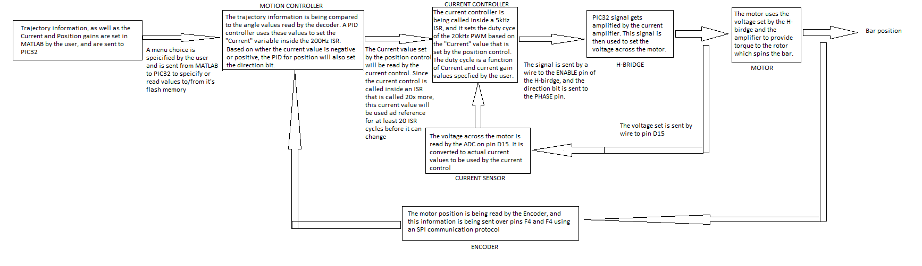

6)

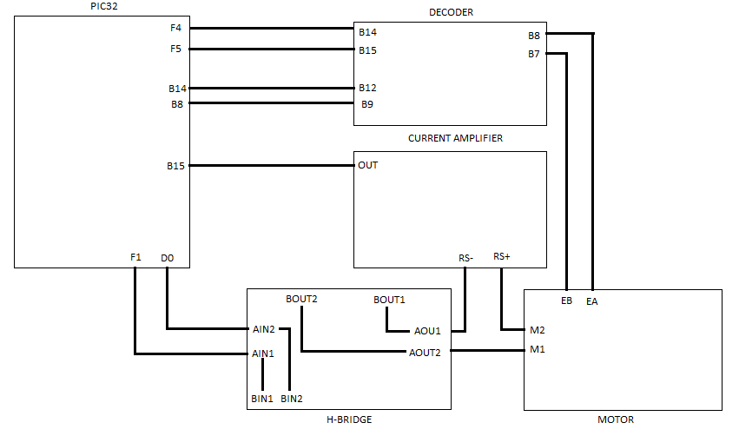

28.4.9

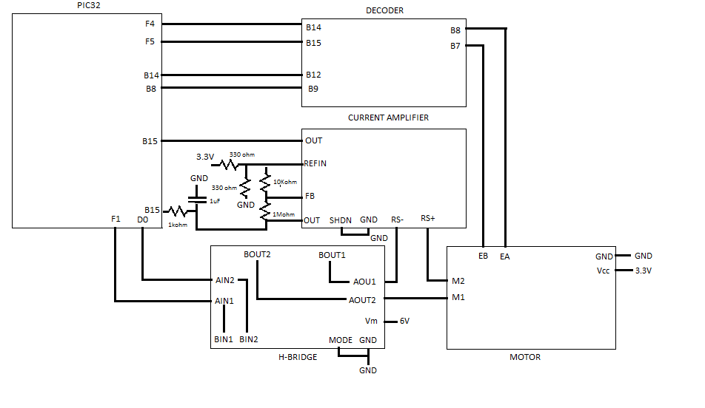

28.4.10

5)

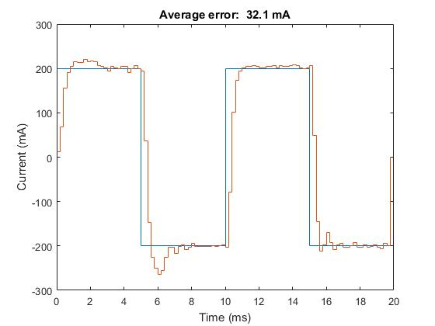

The following is the graph of current tracking without current integral gain.

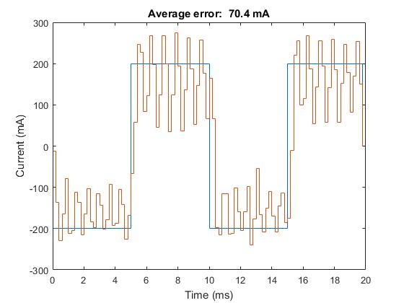

28.4.12

5) Graphs attached, named 28_4_12_5_step1, 28_4_12_5_step2 for step references,

and 28_4_12_cubic for cubic reference.

Current: Kp = 1 (units of Duty cycle counts / mA) Ki = .3 (units of Duty cycle counts/ (mA * s)

Position: Kp = 1 (mA/encoder counts) Kd = 20 (s * mA/encoder counts) Ki = .1 (mA/(s * encoder counts))

Step tracking is with reference of [0,0;1,90;2,180;3,90;4,0;5,0] and [0,0;1,90;2,0;3,180;4,0;5,0]

Cubic tracking is with reference of [0,0;1,90;2,0;3,180;4,0;5,0]

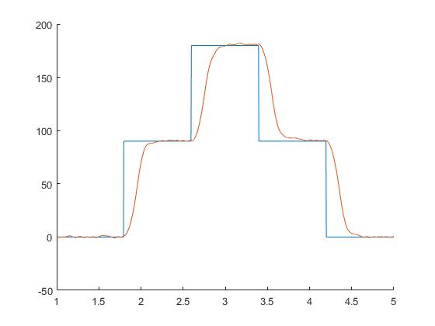

Figure 1 28_4_5_1_step1

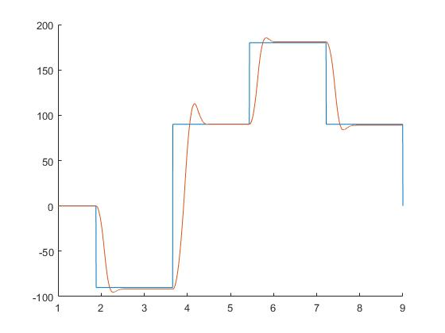

Figure 28_4_5_1_step2

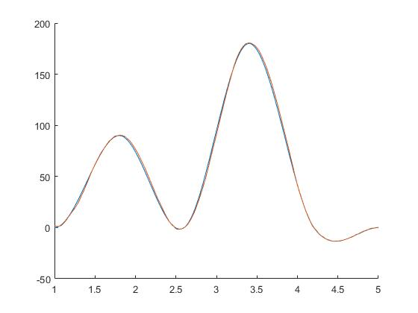

Figure 3 18_4_12_5_cubic